**Data Visualization Project in Python  
(by Balázs Boldogh)**

For this project I decided to create visualizations from a dataset found on Kaggle.  
This is a dataset containing used cars listed for sale in Germany and can be accessed via this link: <https://www.kaggle.com/datasets/ander289386/cars-germany/>

This dataset consists of a single csv file which contains information about cars including:

* manufacturer
* model
* fuel type
* transmission type
* registration year
* price
* mileage
* offer type (used or pre-registered)

By using **pandas** and **matplotlib** I created the following charts from the data:

1. Total number of manual and automatic cars compared
2. Manual and automatic cars by year
3. Manual and automatic cars by manufacturer
4. Average car price by manufacturer
5. Average horsepower by manufacturer
6. Manufacturer market share
7. Fuel type market share

The research clearly indicates and validates the existence of ongoing trends in the landscape of the car industry. With the following charts I wish to illustrate specific shifts in the car market with relevant examples from the used car market of today’s Germany.

**Example 1  
Total number of manual and automatic cars compared**

In this example you can see that manual cars account for twice as much of the current market as automatics. This example however, is incomplete without showing that this rate used to be significantly lower in the previous years. To illustrate this let’s look at example 2.

**Example 2  
Total number of manual and automatic by year**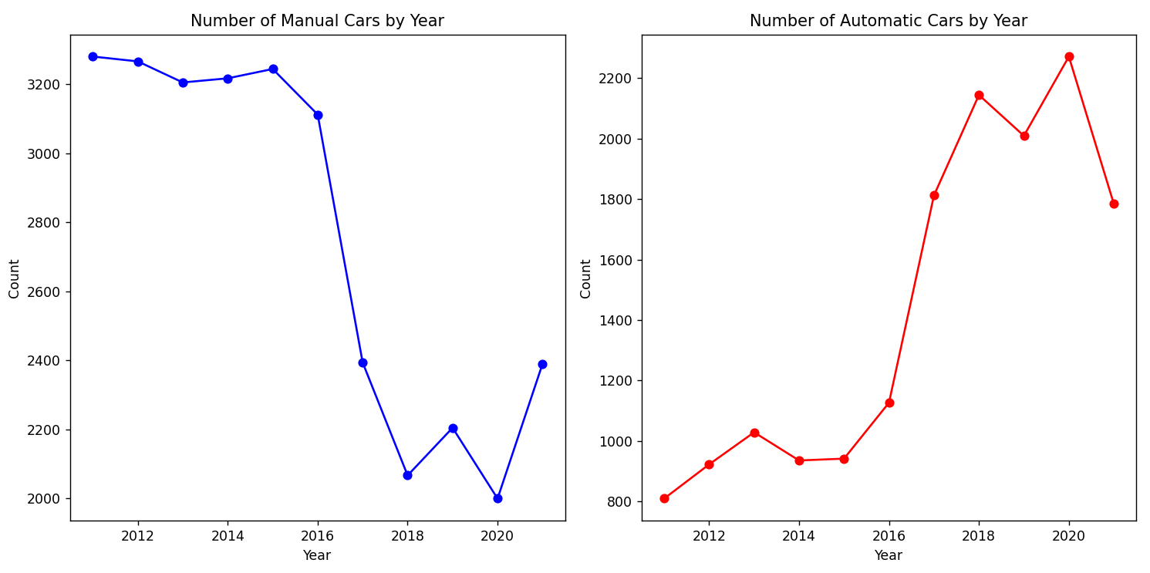

With this graph you can clearly pinpoint a shift in the market. Between 2016 and 2018 the number of manuals plummeted, while the number of automatics essentially tripled.

**Example 3  
Total number of manual and automatic cars by manufacturer**

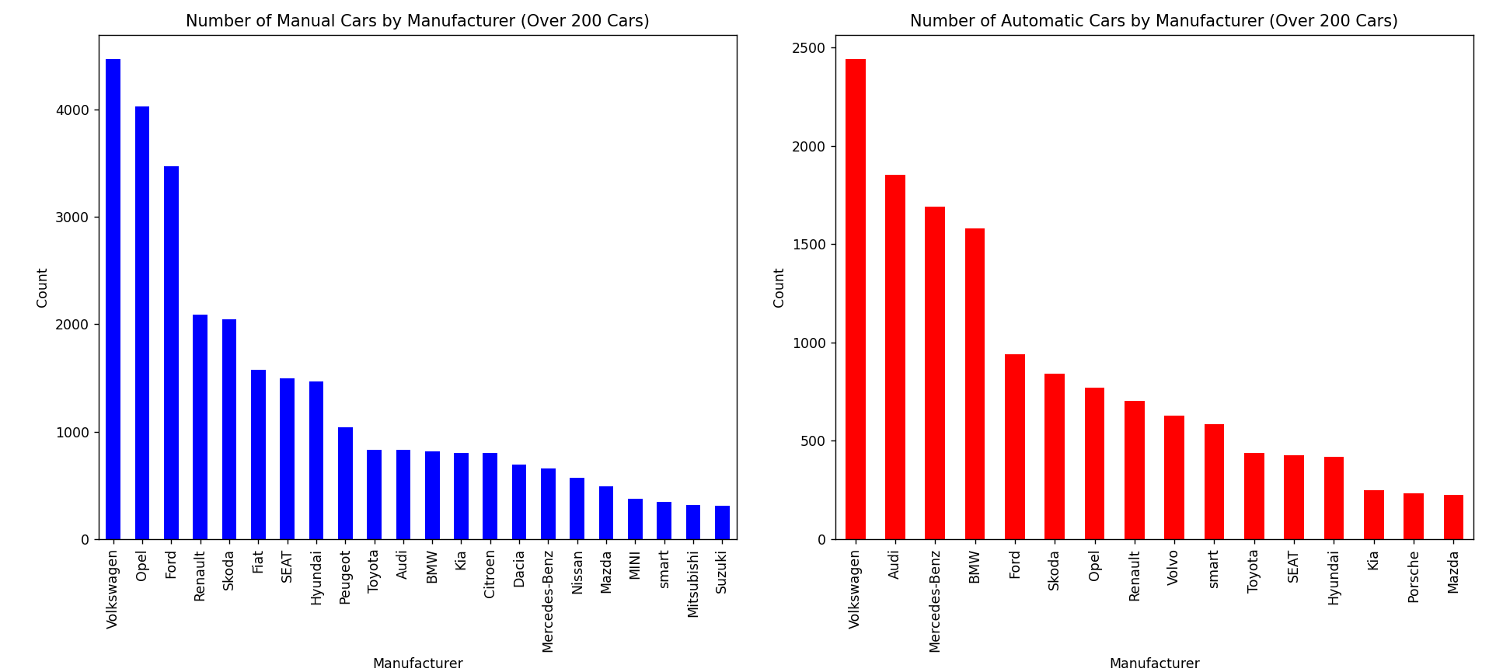

Certain manufacturers might still make a majority amount of manual cars, however it seems that the market has about 1/3 automatic and 2/3 manual. This number is only rising indicated by the previous graph in Example 2. Volkswagen seems to make the most amount of cars in both categories. Their cars are extremely popular in Europe because of their reasonable price range. Now let’s look at how others compare when it comes to affordability.

**Example 4  
Average price by Manufacturer**

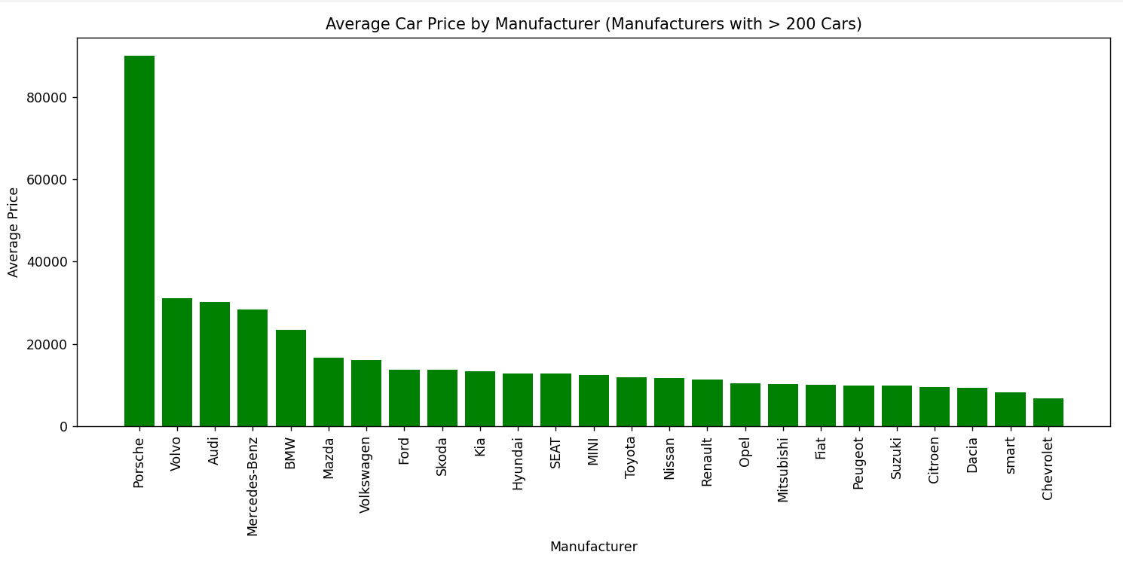

Sport and luxury brands can be clearly seen on the top with Porsche sticking out high above the rest. The reason Porsches have such an extreme average price is because they don’t have mid or low price range cars on offer like Mercedes, BMW or Volkswagen. They strictly manufacture high performance high comfort machines, which people are willing to pay over tens or hundreds of thousands of euros for.

**Example 5  
Average horsepower by manufacturer**

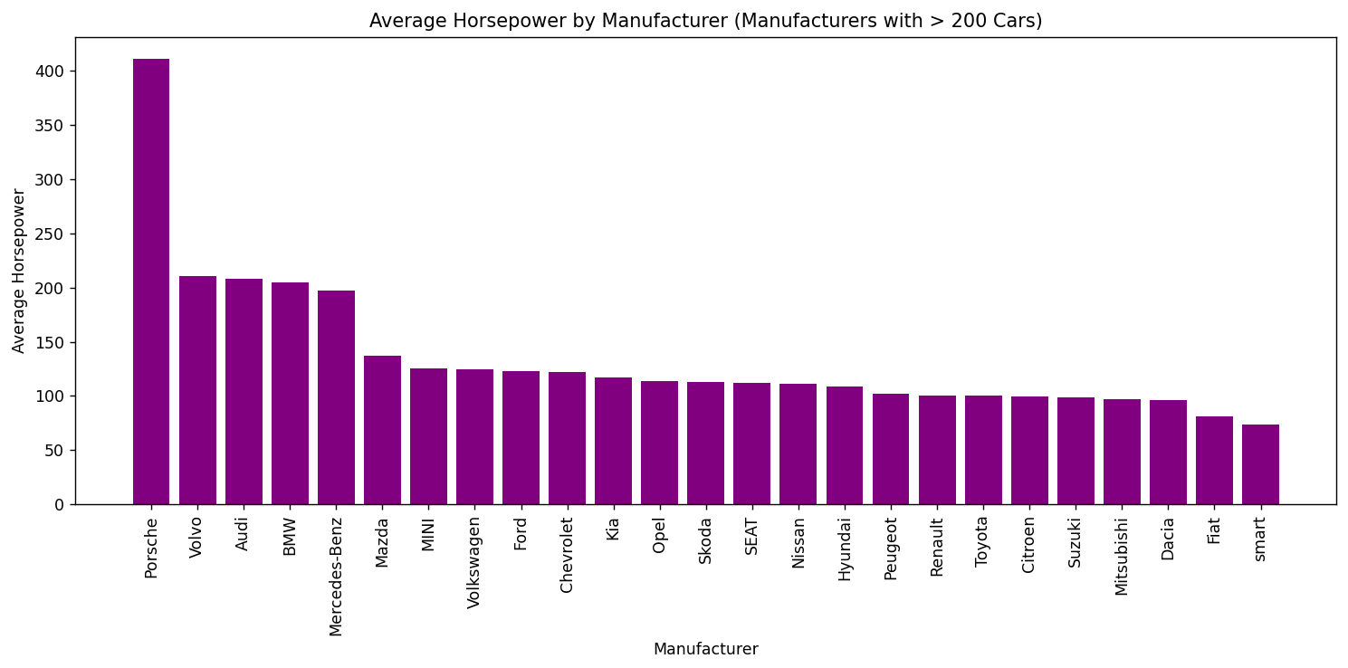

This chart correlates well with the previous example, because more expensive cars generally provide more powerful engines with significantly more horsepower. Porsche is still comfortably at the top here, but in market share it is a completely different scenario.

**Example 6  
Market share by manufacturer**

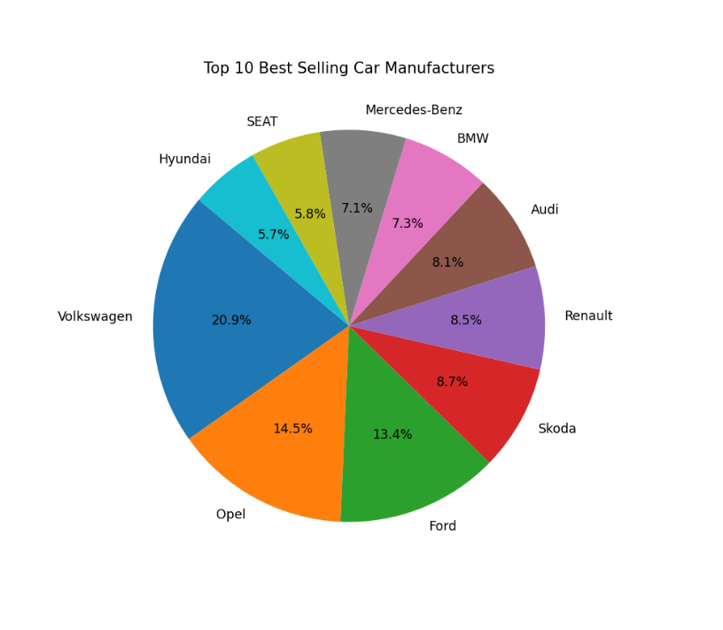

Here, Porsche doesn’t even crack the top 10. Brands like Volkswagen and Opel sell significantly more cars because high performance sportscars are too expensive, impractical or difficult to maintain for most people. Even at a lower price, economy car brands generate a lot more overall volume and revenue than luxury or sports vehicles.

**Example 7  
Fuel type market share**

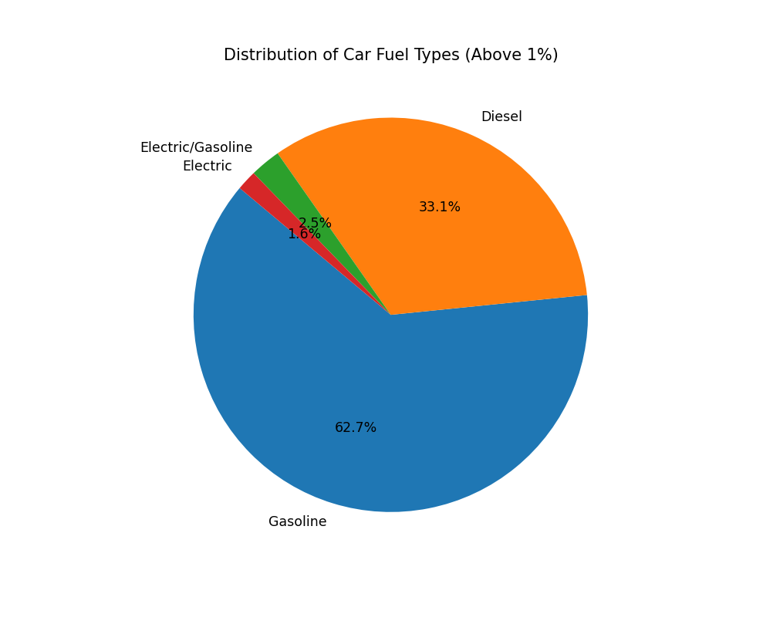

This pie-chart doesn’t seem to indicate that gasoline and diesel powered vehicles will be falling out of favor any time soon. However, if you look at the trend of recent years you might get a completely different picture.

**Example 8

Back in 2011, hybrid and electric vehicles were extremely rare. 10 years later in 2021 however, they are approaching the number of diesel powered vehicles and competing for the second most popular option. Hybrid and electric cars have taken a significant chunk of the market in a relatively short amount of time. Gasoline powered cars are also getting more popular, indicating that the world is moving away from diesel.